- What is SDLC
Ans. Software development life cycle is a structure imposed on the development of the software product that defines the process for planning, implementation, testing, documentation, deployment, ongoing maintenance and support.

- What is agile methodology?
Ans. process models with focus on process adaptability and customer satisfaction by rapid delivery of working software product.

- What is SRS
Ans. A software requirements specification (SRS) is a complete description of the behaviour of the system to be developed.

- What is oops
Ans. Identifying objects and assigning responsibilities to these objects.

- Write Basic Concepts of oops
Ans.
- object
• Class
• Encapsulation
• Inheritance
• Polymorphism- Overriding
− Overloading
• Abstraction

- What is object
Ans.
- An object represents an individual, identifiable item, unit, or entity either real or abstract with well-defined role in the problem domain.
- An “object” is anything to which a concept applies.
- This is the basic unit of object-oriented programming
- That is both data and function that operated on data are bundled as a unit called as object.

- What is class
Ans.
- Class is define as a blueprint for an object.
- Class represents an abstraction of the object and abstracts the properties and behaviour of that object.

- What is encapsulation
Ans.
- Encapsulation is the practice of including in an object everything it needs hidden from other objects. The internal state is usually not accessible by other objects.
- It is a process of wrapping up of data and behaviour of an object into a single unit.

- Inheritance means that one class inherits the characteristics of another class. This is also called a relationship.
- This is a very important concept of object oriented programming helps to reduce the code size.

- What is polymorphism
Ans.
- having many forms
- it allows different objects to respond to the same message in different ways, the response specific to the object.
- The ability to change in form is called polymorphism.

- What is RDBMS
Ans.
- It is the basis for SQL and for all modern database systems like MS SQL server, IBMDB2, Oracle, MySQL and Microsoft access.
- Which is based on relational database model.

- What is SQL
Ans.
- SQL is Structured Query Language, which is a computer language for storing, manipulating an retrieving data stored I relational database.

- Write SQL Commands
Ans.
- DDL – Data Definition Language
- DML – Data Manipulation Language
- DCL – Data Control Language
- DQL – Data Query Language

- Draw Usecase on Online book shopping

Ans.

Online book shopping
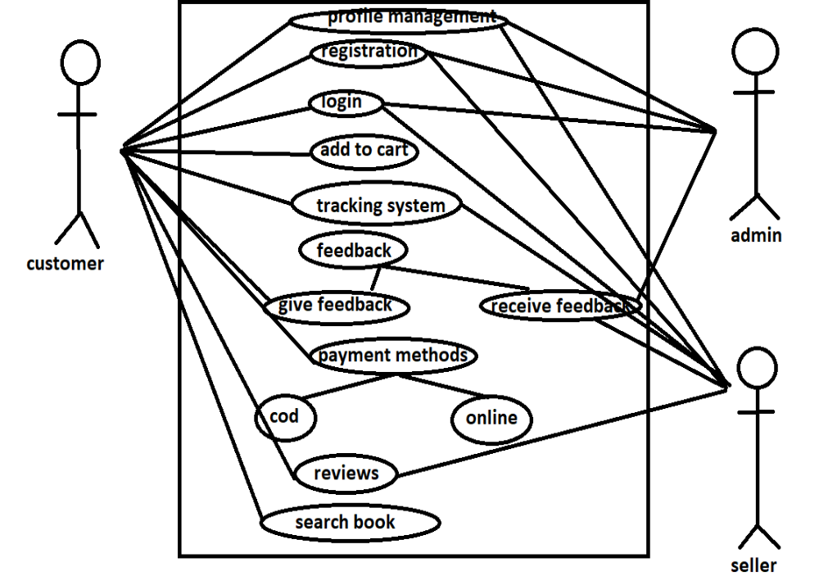

- Draw Usecase on online bill payment system (paytm)

Ans.
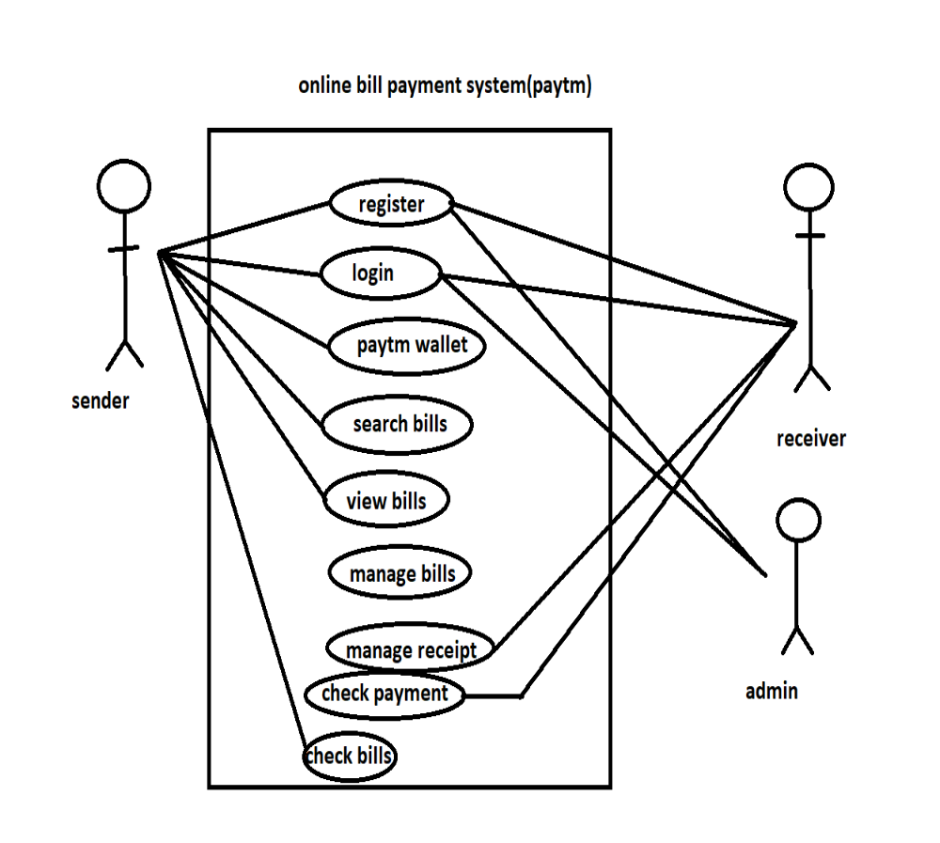

- Write SDLC phases with basic introduction
Ans.

Requirements collections/gathering | Establish customer needs
Analysis  design | Model and soecify the requirements-what  Model and specify the solution
implementation | Construct a solution in software
testing | Validation and the soltion against the requirements
maintainence | Repair defect and adapt the solution to new requirements

- Explain Phases of the waterfall model
Ans.
• Requirements are very well documented, clear and fixed.
• Product definition is stable.
• Technology is understood and is not dynamic.
• There are no ambiguous requirements.
• Ample resources with required expertise are available to support the product.
• The project is short.
- The classical development lifecycle models the software development as step-by-step “waterfall” between the various development phases.

- Write phases of spiral model
Ans.
- There are four phases:
- Planning: determination of objectives, alternatives and constrains.
- Risk analysis: analysis of alternatives and identifications/resolution of risks
- Engineering: development of the next level product
- Customer evaluation: assessment of the result of engineering

- Write agile manifesto principles
Ans.
• Individuals and interactions - in agile development, self-organization and motivation are important, as are interactions like co-location and pair programming.

• Working software - Demo working software is considered the best means of communication with the customer to understand their requirement, instead of just depending on documentation.

• Customer collaboration - As the requirements cannot be gathered completely in the beginning of the project due to various factors, continuous customer interaction is very important to get proper product requirements.

• Responding to change - agile development is focused on quick responses to change and continuous development.

- Explain working methodology of agile model and also write pros and cons.
Pros
• Is a very realistic approach to software development
• Promotes teamwork and cross training.
• Functionality can be developed rapidly and demonstrated.
• Resource requirements are minimum.
• Suitable for fixed or changing requirements
• Delivers early partial working solutions.
• Good model for environments that change steadily.
• Minimal rules, documentation easily employed.
• Enables concurrent development and delivery within an overall planned context.
• Little or no planning required
• Easy to manage
• Gives flexibility to developers
Cons
• Not suitable for handling complex dependencies.
• More risk of sustainability, maintainability and extensibility.
• An overall plan, an agile leader and agile PM practice is a must without which it will not work.
• Strict delivery management dictates the scope, functionality to be delivered, and adjustments to meet the deadlines.
• Depends heavily on customer interaction, so if customer is not clear, team can be driven in the wrong direction.
• There is very high individual dependency, since there is minimum documentation generated.
• Transfer of technology to new team members may be quite challenging.

- Draw use case on Online shopping product using COD.
Ans.

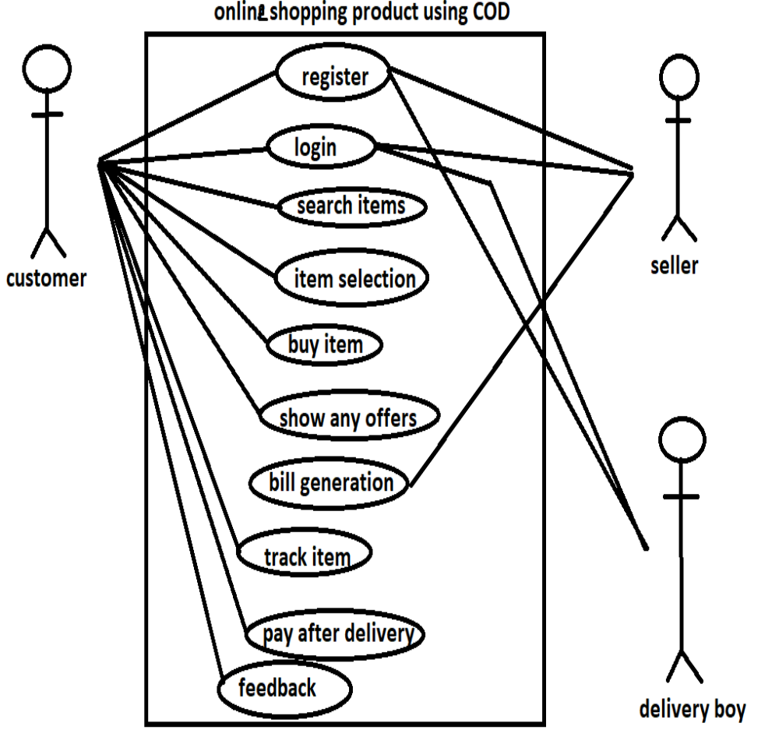

- Draw usecase on Online shopping product using payment gateway.
Ans.

